Getting Started
Prerequisites 1
Visual Studio 1
NuGet 1
Access to file share 1
Browsers 1
Creating your first Maqs solution 2
Adding a new page object 4
Adding a new test class 5
Using Maqs Outside Magenic 5
Notes 6

Prerequisites

Visual Studio
2010, 2012, 2013 or 2015
Professional, Premium or Ultimate

NuGet
https://docs.nuget.org/consume/installing-nuget
*NuGet is included with Visual Studio 2015

Access to file share
\\magenic.net\fileshare\Installs\QA Tools\QAT Framework\
*If you are working outside the Magenic intranet see "Using Maqs Outside Magenic " for out of network instructions

Browsers
Technically no browser needs to be installed, but we strongly suggest having Firefox, Chrome and IE installed.

Creating your first Maqs solution
- Open Visual Studio
- Create a new solution (FILE -> New -> Project)
- Select the "Maqs Framework – Selenium" project template (Templates -> Visual C# -> Magenic Test)
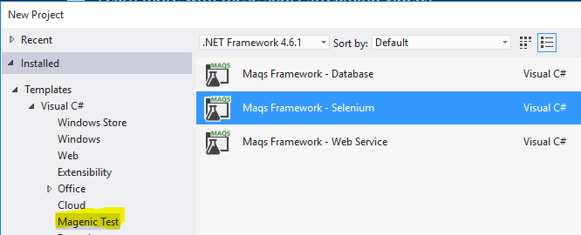
- Update the Name, Location and Solution name appropriately
* Leaving the defaults will work if you a just doing a proof of concept
- Click OK and the solution will be created
- *Note* Visual Studio (2013 and below) will tell you to enable NuGet package restore, this must be done in order to compile the code
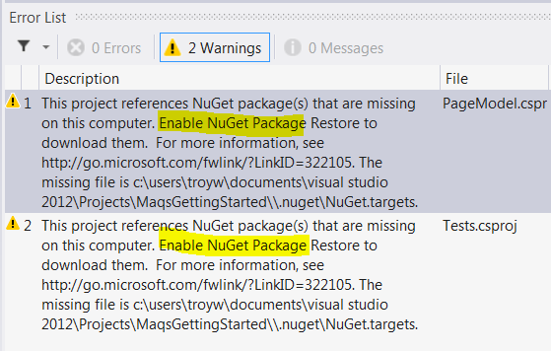
- Right click the solution in the solution explorer and enable NuGet package restore
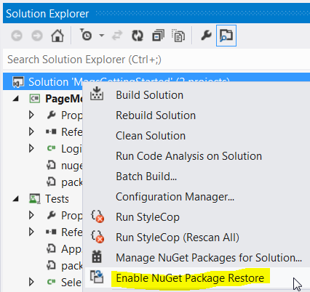
- Confirm you want to enable restore
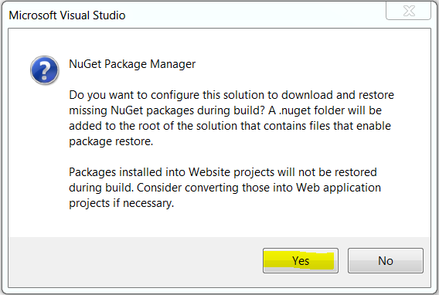
- Open the test explorer window
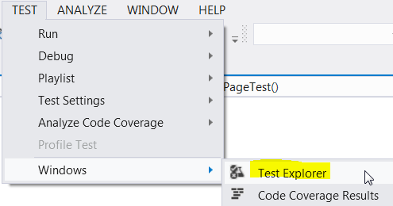
- Run all the tests
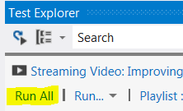
* Default template assumes Chrome
- The test results will be displayed in the test explorer
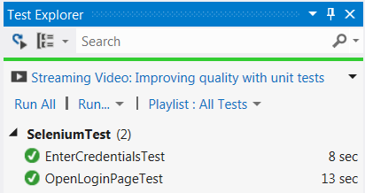

Adding a new page object
- Right click on the PageModel project and add a new item
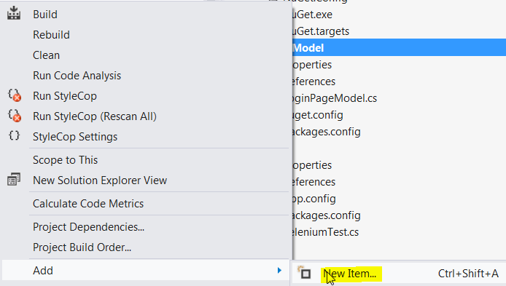
- Select the Maqs Selenium Page Model Class, give it a useful name and click "Add"
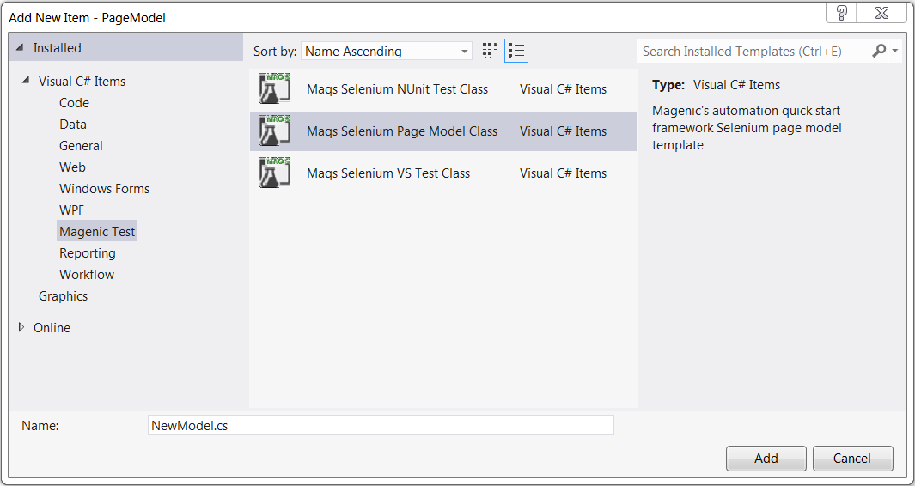
- Updated the new page model to reflect a page of your choice

Adding a new test class
- Right click on the Tests project and add a new item
- Select the Maqs Selenium VS Test Class, give it a useful name and click "Add"
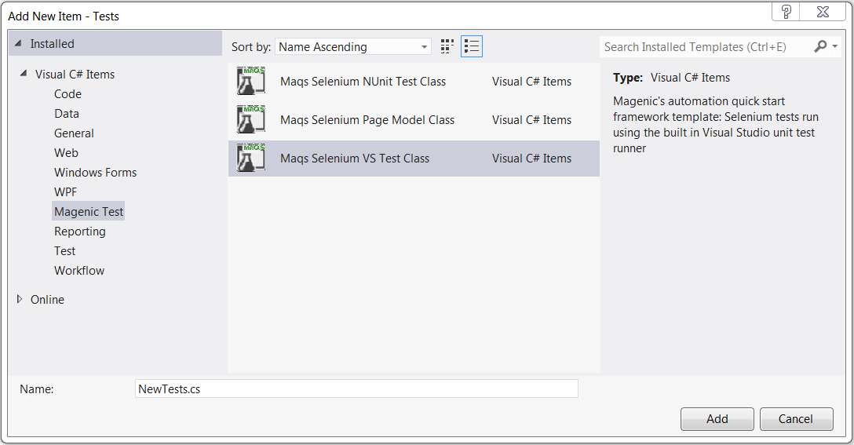

Using Maqs Outside Magenic
The MAQS nuget packages are housed on Magenic's intranet.
This is a problem when trying to user MAQS from outside the Magenic intranet.
There are two simple ways to address not have Magenic intranet access.
- Copy the MAQS nuget package into a network share in your customer's intranet
  - Copy the .nupkg file into the shared folder
  - Update the "intranet repository" location in the nuget.config file
*This will be the path to the shared folder
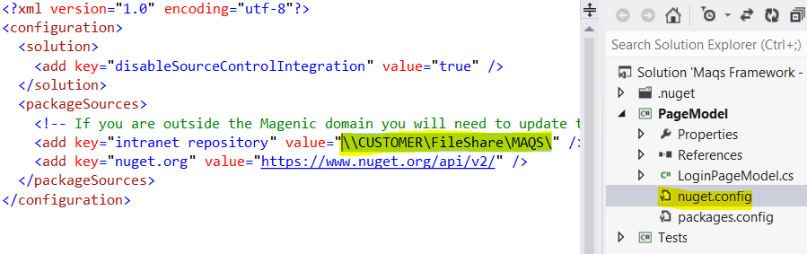
- Add the nuget package to your code in an externals folder
  - Create an "Externals" folder under your solution directory
*Use Windows Explorer to do this step
  - Copy the .nupkg file into the "Externals" folder
*once again using Windows Explorer
  - Add the .nupkg to your solution as an "Existing Item"
  - Rename the "Solution Items" folder "Externals"
*This step in not necessary, but makes the solution more understandable
  - Update the "intranet repository" location in the nuget.config file
*The value will be the relative path form the ".nuget" folder to the "Externals" folder
*If you follow the instruction the value would be "..\Externals\"
*The ".nuget" folder is created by nuget as a child of the solution folder
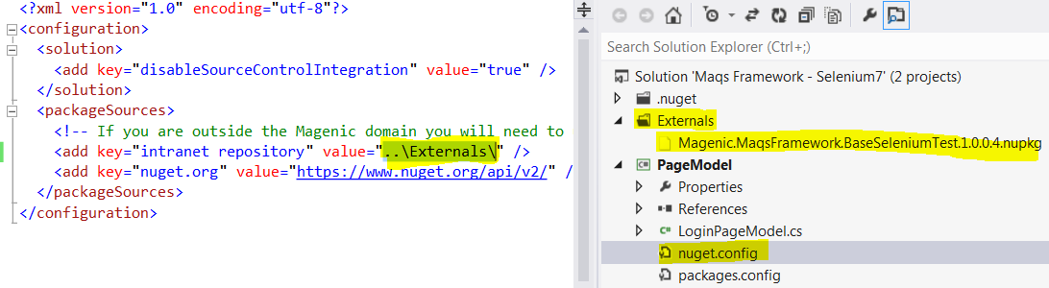

Notes
- NEVER EVER commit the nuget packages folder
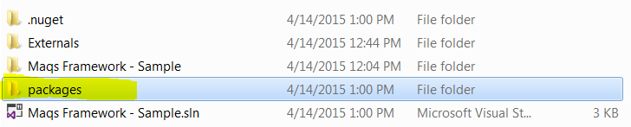
*You will break your build if you commit this folder and its content
- If you update the Nuget version of the Chrome, IE or PhantomJS web driver you will need to update your post build event to copy the new web driver to your build directory
